Develop a vb project to display the multiplication table for the given number.

Form design:

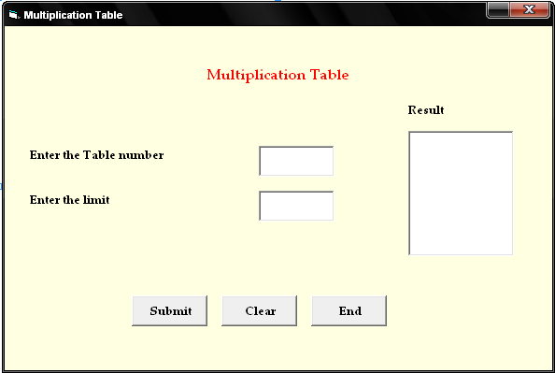

Properties:

Contol | Name | Caption
Text1 | Text1
Text2 | Text2
List1 | List1
Command1 | Cmdsubmit | Submit
Command2 | Cmdclear | Clear
Command3 | Cmdend | End

5.Multiplication Table

Aim:
To develop a vb project to display the multiplication table for the given number.

Coding:
Private Sub Cmdsubmit_Click()
Dim a, b, c, i As Integer
a = Val(Text1.Text)
b = Val(Text2.Text)
For i = 1 To b
c = i * a
List1.AddItem (a & "*" & i & "=" & c)
Next i
End Sub

Private Sub Cmdclear_Click()
Text1.Text = " "
Text2.Text = " "
List1.Clear
End Sub

Private Sub Cmdend_Click()
End
End Sub

Output:

